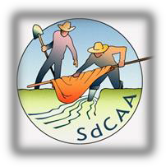

The Sangre de Cristo Acequia Association Memorial Scholarship Fund

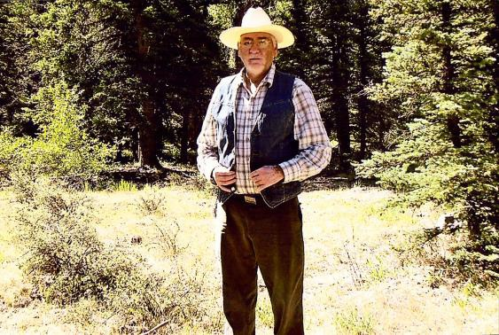
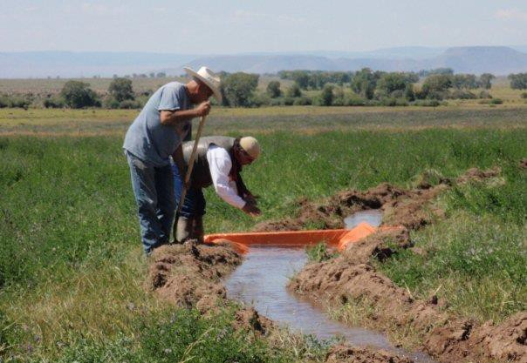

Following the sudden deaths in 2016 of two valued board members, the SdCAA established a scholarship fund in their honor. Felix Lopez and Joe Gallegos were devoted to acequia traditions and lifeways; they also recognized the importance of both academic and practical education in sustaining the acequia way of life under changing conditions. To continue their work, the scholarship fund will help defray the expenses of college courses for area students, as well as internships and practical training for acequia parciantes. The Acequia Association will offer a single $500 scholarship for and students and two $150 practical education grants each year as we are growing the grant fund.

Scholarships:
The fund will offer high school seniors in Costilla, Conejos, Huerfano and Las Animas counties an opportunity to receive a $500-dollar scholarship to the school of their choice. Applicants must be accepted to a college or have applications in the review process. Scholarship applications will open September 1, 2018

Practical Education Grants:
This grant provides up to $150 of reimbursement for parciantes to attend workshops and trainings to both deepen and broaden their agricultural skill sets. To obtain reimbursement interested parties will need to provide a brief overview of their workshop and expense receipts to the SdCAA board at their regular monthly meeting ( the second Tuesday of each month).

For more information about these learning opportunities please contact Mathew Valdez at 719-672-0810. Also watch our newsletter, El Parciante, for updates.

Interested in donating?
Contact the SdCAA office at 719-672-0180. Contributions can be addressed to the SdCAA Memorial Scholarship Fund, and mailed to PO Box 721, San Luis, CO 81152. We are a 501 c (3) non-profit organization so your donation is tax deductible. The Acequia Association will send you a return receipt acknowledging your donation.

