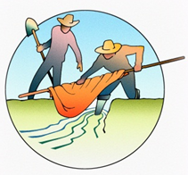
AGENDA
Saturday, October 11th Centennial School Commons
8:00 AM | Registration with Coffee and pastries provided by the Costilla Conservation District
8:30 AM | Welcome and Agenda
 | Sarah Parmar, Sangre de Cristo Acequia Association
8:45 AM | Keynote – Acequia Cohesion and the Colorado Water Plan
 | Edward Vigil, Colorado Representative
9:15 AM | Understanding Bylaws and Incorporation
Sarah Krakoff and Megan Gutwein, University of Colorado Law School
and Eugene Jacquez, Acequia del Cerro
10:15 AM | BREAK
10:25 AM | Resolving Conflicts on the Acequia
 | Ryan Golten, CDR Associates
12:00PM | LUNCH – featuring our student poster and poetry contest winners  sponsored by the Costilla County Conservancy District
1:15 PM | Community engagement and local water organizations
Sangre de Cristo Acequia Association, Sarah Parmar
Costilla County Conservancy District Board, Ronda Lobato
1:45 PM | NRCS Programs and Partnerships
Season extender successes using EQIP - Charlie Maestas, landowner and Jenny Stricker, NRCS
Protecting land and water with ALE - Sarah Parmar, Colorado Open Lands
3:00 PM | BREAK
3:15 PM | Historical background and status of research on the Hallett Decrees (“Freehold Water”)
Will Davidson and Julia Guarino, University of Colorado Law School, Allan Beezley, P.C.,
Peter Nichols, Berg, Hill,Greenleaf & Ruscitti, LLP
4:30 PM | WRAP UP

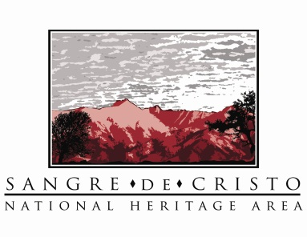
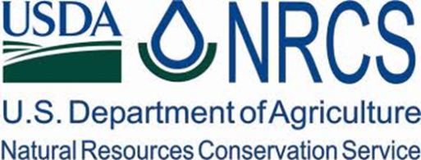
Generously sponsored by:
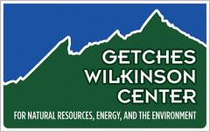

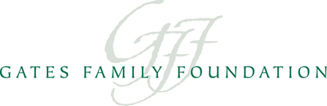
Also made possible by:

